**[01] Professional Discussion based on Portfolio of Evidence (Assessment method 2)**

[[K2.2 & B1.2]](https://live.onefile.co.uk/standards/form.aspx?StandardID=67848&UnitID=RESSLAO_UOE_01_#01) (Pass): Demonstrates examples of advanced mixed media communication, such as presentations, report writing (technical and non-technical) negotiation and influencing

As part of Data Engineering team, I have written multiple technical documentation on our wiki pages, which helped multiple peoples to solve their technical issues.

Let me explain the scenario with examples, we have a 2000 nodes cluster where the Cloudera sandbox was installed and not my organization wants to move into Hortonworks (these two companies merged later).

As part of the migration process there are lot of components where versions are being changes, for some minor version but for some components major versions are being changed, while migration our duty was to ensure everything is working fine in the cluster and no person from Europe region are having issues.

For this I have created a wiki page which helped multiple people on how to execute the hive queries using which parameters on our new cluster.

Likewise, I have created Spark, Tez technical documents which helped multiple people to run their queries smoothly and efficiently.

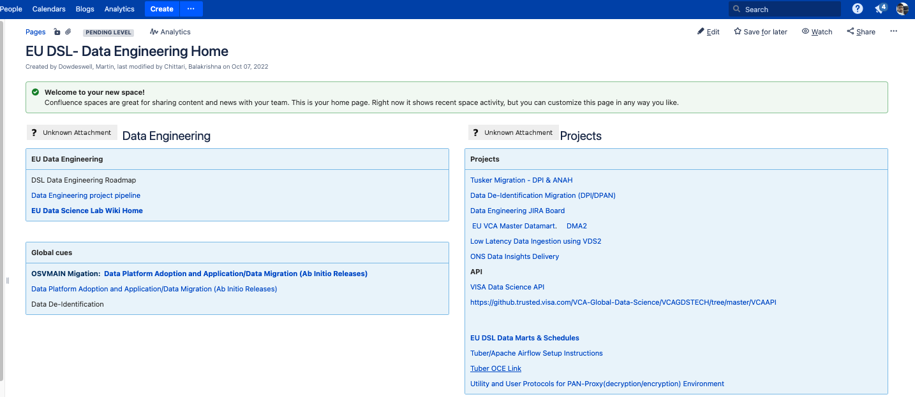

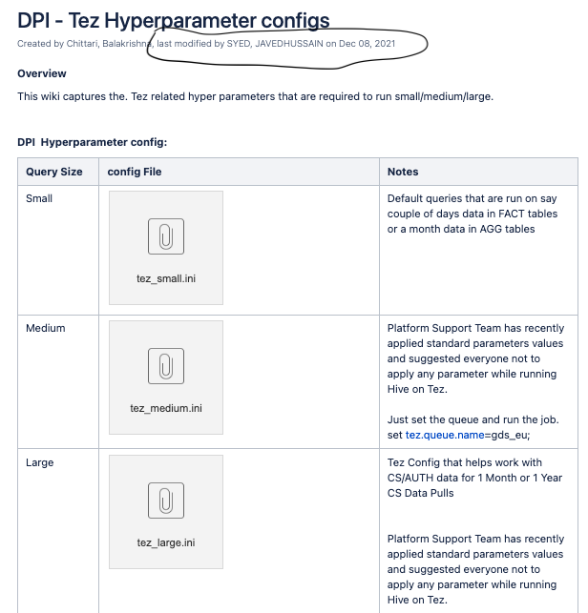

I have also taken multiple session to explain the issues and the solutions, every week I conduct an Office hour to our region to take their issues and solve. This is a kind of support what we provide to the Data Scientist of Europe region.

[[S4.3, B1.3 & B4.3a]](https://live.onefile.co.uk/standards/form.aspx?StandardID=67843&UnitID=RESSLAO_01#06) (Distinction): Explains examples of when they have:Contributed to the knowledge base and understanding of team members via clear interpersonal skills and effective communication including assertiveness and motivation, and the impact this had on the organisation

As part our daily job we always work closely with the Data Scientist team members and will gather the requirements based on their project, while taking the requirements we always suggest them the best standards so that data is efficient, and reliable.

We interact with multiple teams and work based on the priority basis. We follow Agile framework sprint format; every sprint is of 3 weeks and based on the it shows our deliveries.

I have always helped our Data Scientist on technical side starting from design and development and received feedbacks from them. I conduct meetings with then and do a brainstorming which helps them to complete their task on time.

[S4.3, B1.3 & B4.3b]](https://live.onefile.co.uk/standards/form.aspx?StandardID=67843&UnitID=RESSLAO_01#06) (Distinction): Explains examples of when they have:Taken personal responsibility and defended decisions in unpredictable professional situations. (In doing so they demonstrate a clear commitment to personal values of professionalism, ethical practice, inclusivity and ongoing personal development, together with a willingness to plan and manage effective change)

In my entire experience I have defended decision multiple times, one of the technical examples I want to explain which happen recently with my team, the code which was written by one of my peer has not gone through the peer testing and got deployed into Prod which is a major issue.  
  
We have started facing issue in the prod as the code was failing and giving wrong results to the front-end, these thing got escalated at very high level, I got pulled into a call as it was a severe-1 issue we need to solve this within an hour.  
  
During that time as part of my old experience I only know the possible solution is to roll-back the code to our previous version. As have the entire CI/CD pipeline we were able to do that in less than 30 mins, which got solved the problem only the new feature what we want to bring it that was missing which we have planned for our next sprint.  
  
During that time I got a good feedback from my manager as I have taken the responsibility and took a decision where we need to roll-back the code and also I have already setup the entire CI/CD pipeline using which we were able to perform these thing, else it was very much difficult.

Whenever we push the code to git there is a Jenkins pipelines runs and deploys the code into artifacts. This entire pipeline was built by me and my team members.

Whenever we have a plan to push the code to Production from QA there will be a proper CRQ Change Request we create and will deploy our code as per the schedule.

[[S4.1, B1.1 & B4.1]](https://live.onefile.co.uk/standards/form.aspx?StandardID=67848&UnitID=RESSLAO_UOE_01_#06) (Pass): Explains how they have utilised interpersonal skills, communication and assertiveness to persuade, motivate and influence

As part of Data Engineering team, we always need to interact with Data Scientist team and sometimes we do also will be get included in the client calls to understand the requirements in a better way.

We always come up with the ideas and communicate well with the team and help them to complete their project on time.

As one of the projects Datamart where Data Scientist have issue while accessing the global datamart table, we have come up with Europe region datamart which helped them to extract the data in very less time. This helped everyone to access data in no time where earlier they must wait for 10-15 min just to extract the dataset.

We have helped them in the low-latency mart, as there is a new requirement for the clients, they need an analysis report for every 10 min and we don’t have that feature, I have started designing the application in Kafka and developed one project of a Low Latency. This project got a good feedback and help our clients to receive data for every 10 min.

This is the low latency behaviour we have come up with and the new tech stack we have introduced in our project. Received multiple feedbacks on this project.

